**Assignment 2 –**

**Install ansible and connect the nodes to master and execute the ad-hoc commands on ansible master node vm and test the packages installed or not.**

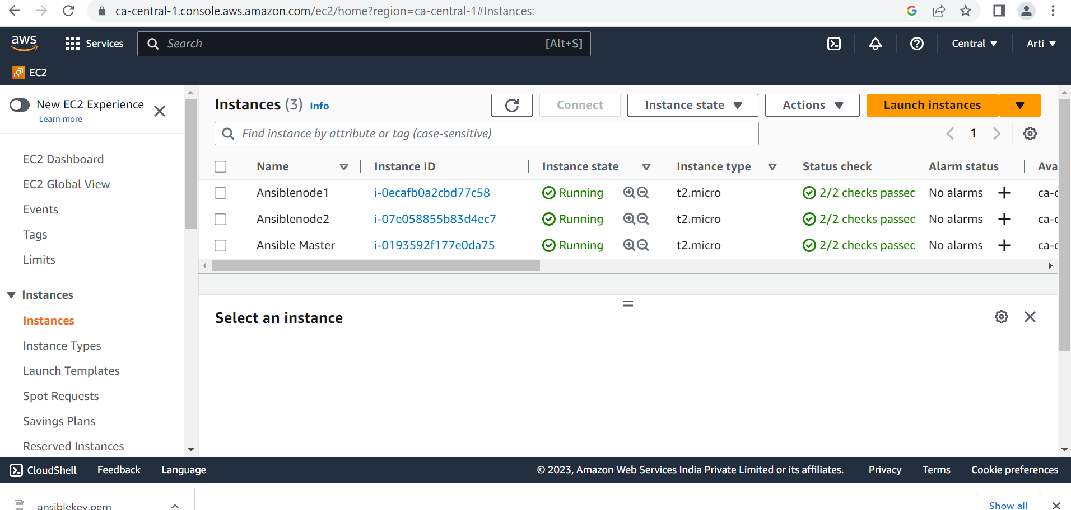

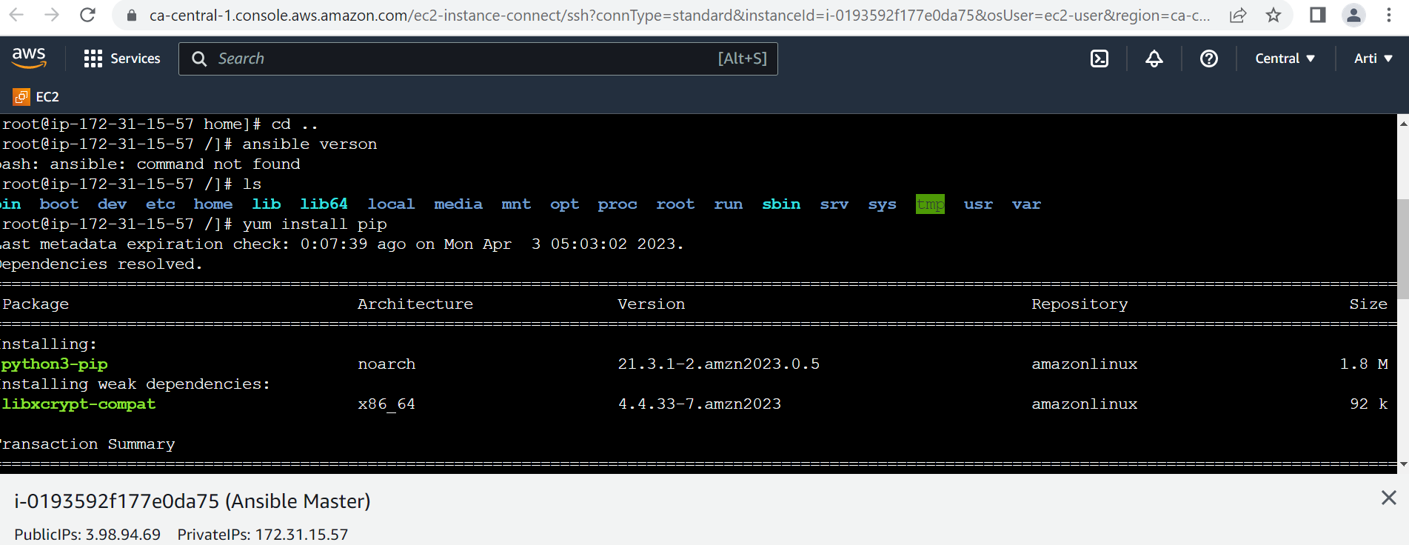

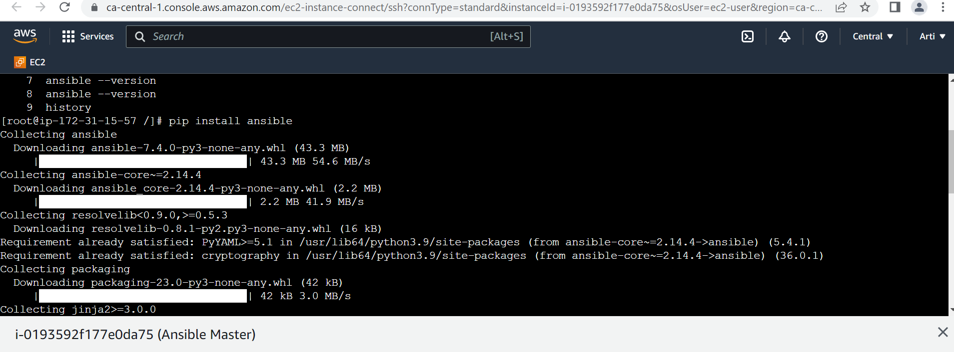

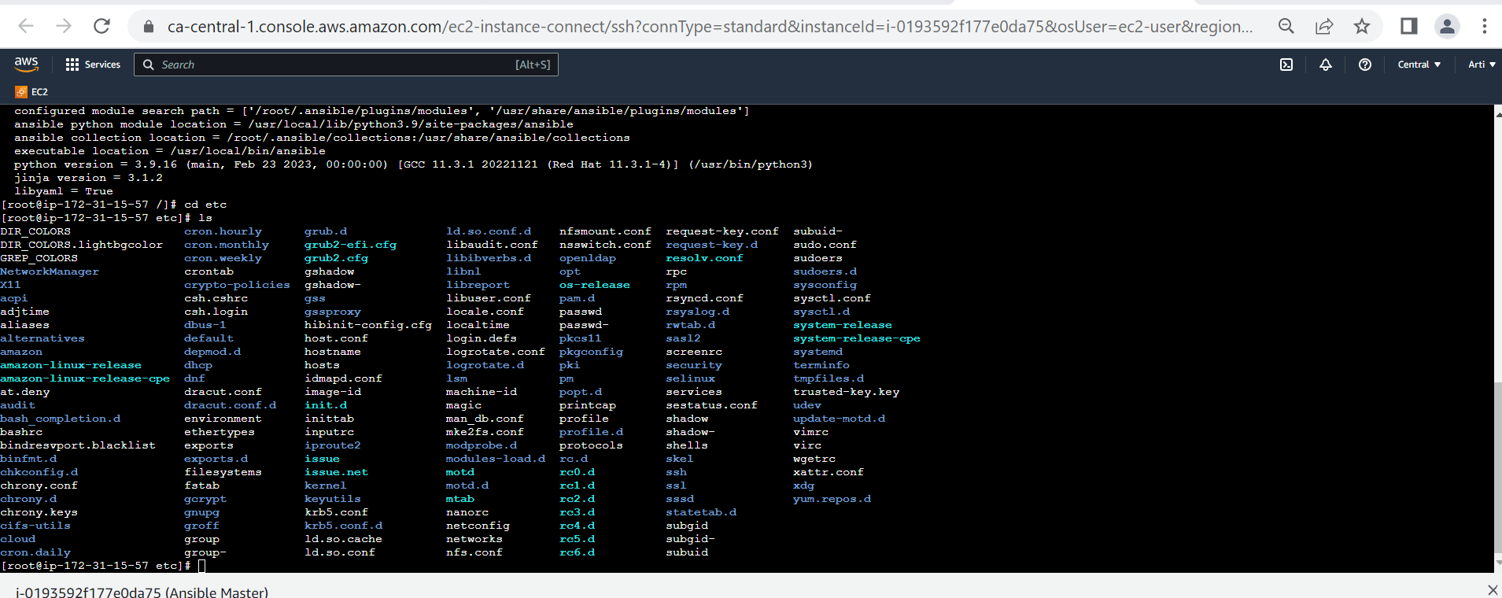

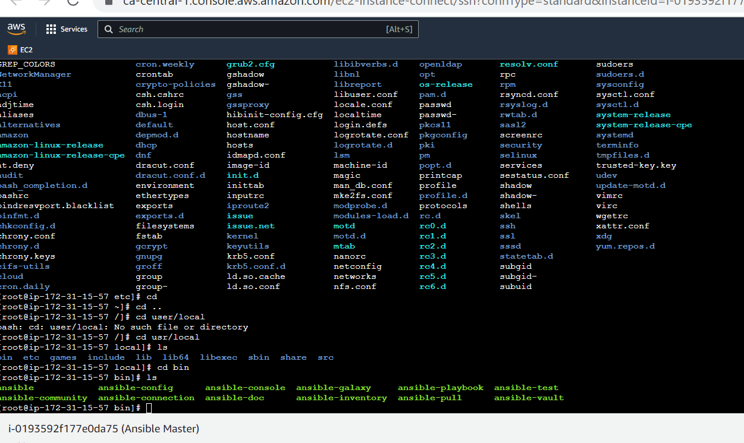

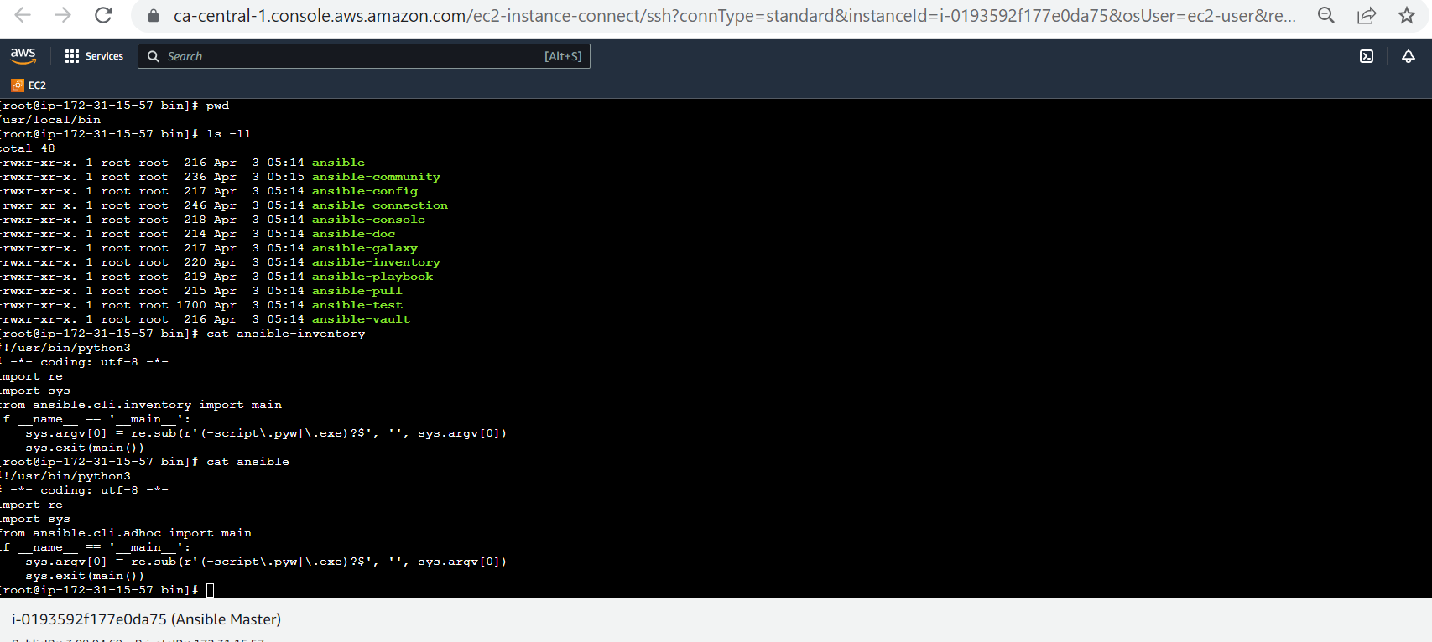

**SHH**

[Installing Ansible on specific operating systems — Ansible Documentation](https://docs.ansible.com/ansible/latest/installation_guide/installation_distros.html#installing-ansible-on-ubuntu)

$ sudo apt update

$ sudo apt install software-properties-common

$ sudo add-apt-repository --yes --update ppa:ansible/ansible

$ sudo apt install ansible

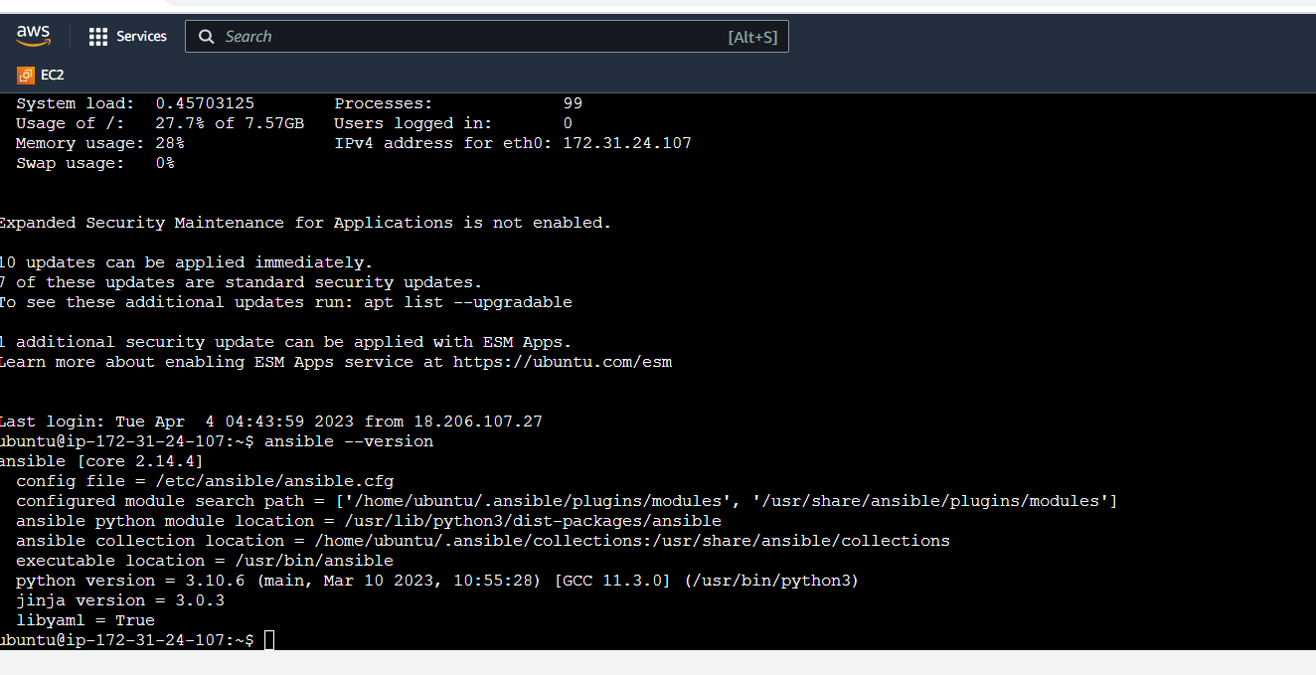

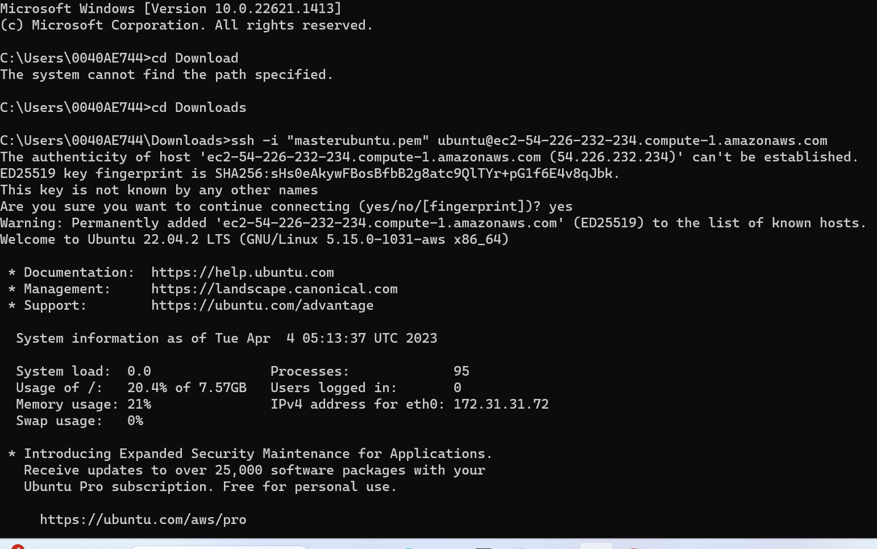

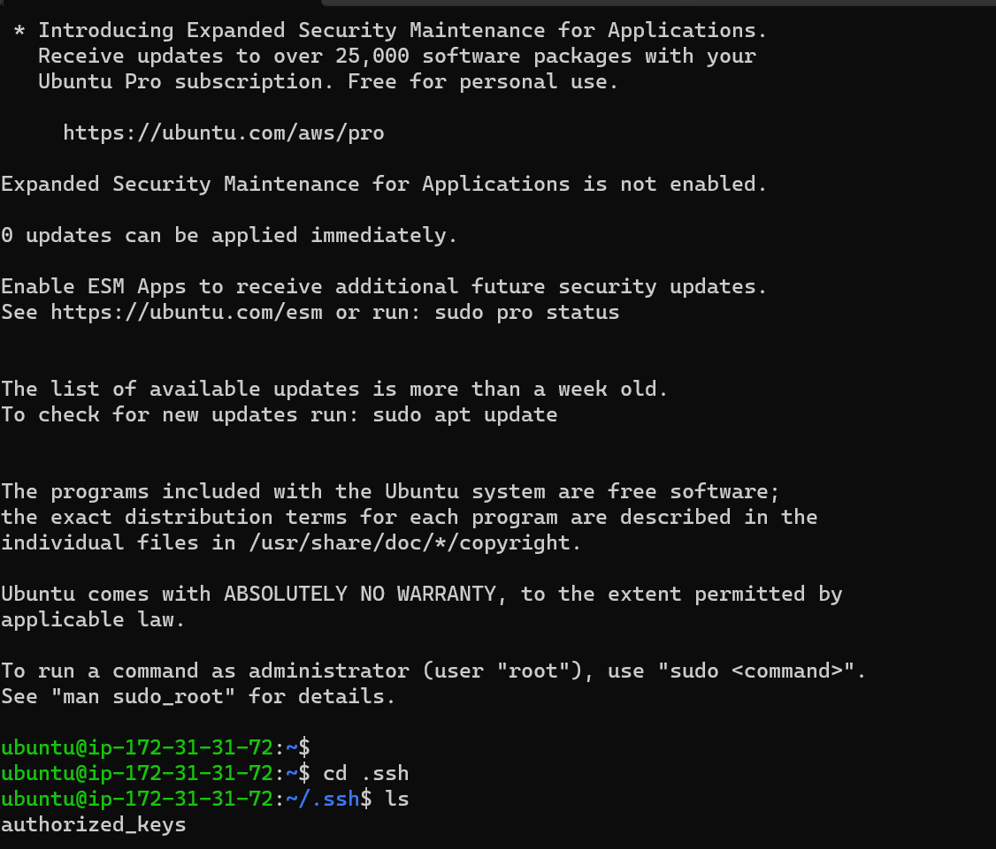

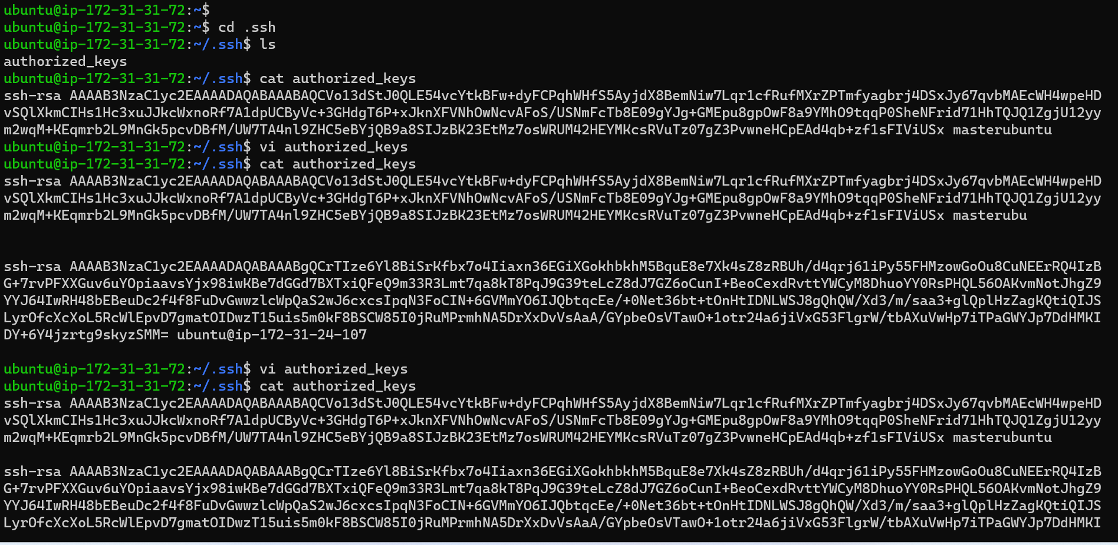

**Node2**

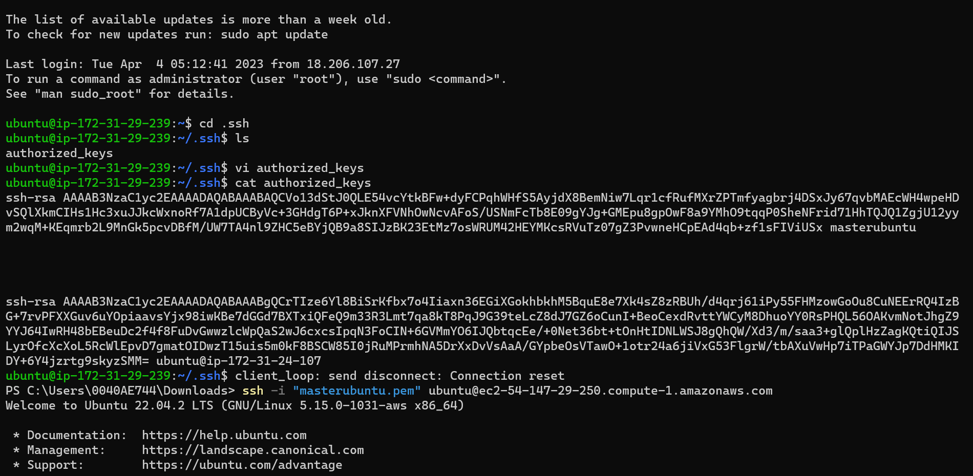

**Master**

